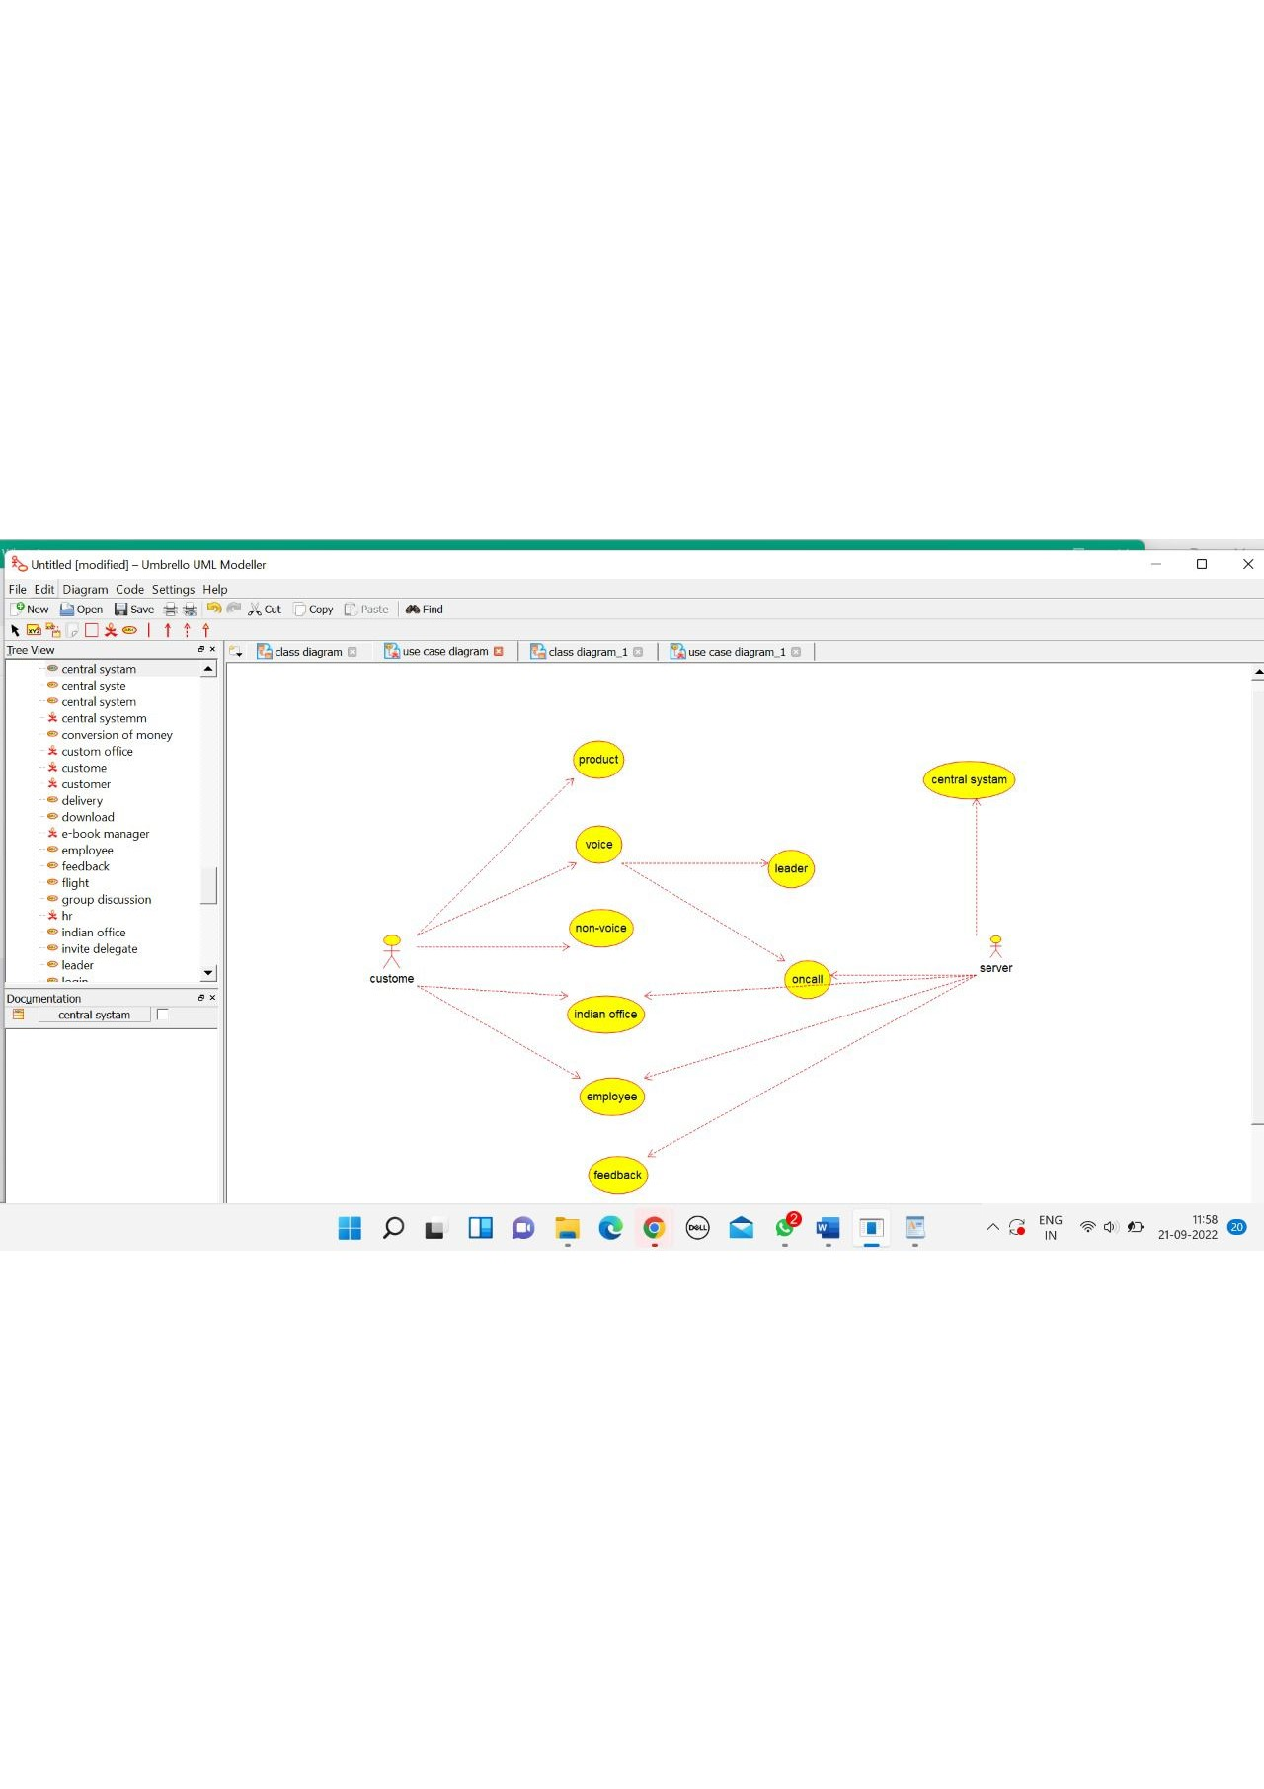

CUSTOMER

/**

* Class customer1

*/

public class customer1 {

//

// Fields

//

private void name;

private void purchase_product;

//

// Constructors

//

public customer1 () { };

//

// Methods

//

//

// Accessor methods

//

/**

* Set the value of name

* @param newVar the new value of name

*/

private void setName (void newVar) {

name = newVar;

}

/**

* Get the value of name

* @return the value of name

*/

private void getName () {

return name;

}

/**

* Set the value of purchase_product

* @param newVar the new value of purchase_product

*/

private void setPurchase_product (void newVar) {

purchase_product = newVar;

}

/**

* Get the value of purchase_product

* @return the value of purchase_product

*/

private void getPurchase_product () {

return purchase_product;

}

//

// Other methods

//

/**

*/

public void payment()

{

}

/**

*/

public void feedback()

{

}

/**

*/

public void customer()

{

}

}

DEALER

/**

* Class dealer

*/

public class dealer {

//

// Fields

//

private void name;

private void avaiolability;

//

// Constructors

//

public dealer () { };

//

// Methods

//

//

// Accessor methods

//

/**

* Set the value of name

* @param newVar the new value of name

*/

private void setName (void newVar) {

name = newVar;

}

/**

* Get the value of name

* @return the value of name

*/

private void getName () {

return name;

}

/**

* Set the value of avaiolability

* @param newVar the new value of avaiolability

*/

private void setAvaiolability (void newVar) {

avaiolability = newVar;

}

/**

* Get the value of avaiolability

* @return the value of avaiolability

*/

private void getAvaiolability () {

return avaiolability;

}

//

// Other methods

//

/**

*/

public void payment()

{

}

/**

*/

public void delivery()

{

}

/**

*/

public void dealer()

{

}

}

CENTRAL SYSTEM

/**

* Class central_system_1

*/

public class central_system_1 {

//

// Fields

//

private void store;

private void update;

//

// Constructors

//

public central_system_1 () { };

//

// Methods

//

//

// Accessor methods

//

/**

* Set the value of store

* @param newVar the new value of store

*/

private void setStore (void newVar) {

store = newVar;

}

/**

* Get the value of store

* @return the value of store

*/

private void getStore () {

return store;

}

/**

* Set the value of update

* @param newVar the new value of update

*/

private void setUpdate (void newVar) {

update = newVar;

}

/**

* Get the value of update

* @return the value of update

*/

private void getUpdate () {

return update;

}

//

// Other methods

//

/**

*/

public void storing()

{

}

/**

*/

public void updating()

{

}

/**

*/

public void processing()

{

}

}

